**Acting**

Acting on the modern stage ranges from the psychological realism of Konstantin Stanislavsky (1863-1938) to the sensory assault of Antonin Artaud (1896-1948) to the didactic presentation of Bertolt Brecht (1898-1956), to name only three of the best-known styles. While the range and variety of acting styles is not unique to the modern stage, the self-conscious delineation of those styles—both in relation to and as theories of representation—is. Previously, an actor’s performance—often of a well-known dramatic text—was regarded as his or her own *interpretation* of a role, assessed in relation to other actors’ forays in that part. But with the development of advanced stage machinery, allowing for elaborate scenic and lighting designs, acting became only one of many elements from which to make a theatrical work of art, displacing the actor from the centre to the margins of the creative process. Assuming centre stage were the playwright and director. The passage of an international copyright agreement in 1891 meant that playwrights could exercise more authorial control over their dramatic designs. And, in order to realize the material dimensions of such dramas in performance, the specialized position of the director emerged to coordinate the increasingly complex elements of the production. Consequently, modernist styles of acting developed in relation to the textual and directorial constraints of the newly configured modern theatre.

If the interpretive agency of the star actor diminished in the modern era, that of the supporting actor was enhanced by the move toward ensemble playing and the implementation of a rehearsal system for long runs. Previously, supporting actors played ‘lines of business,’ typed roles that appeared regularly in plays of a specific genre. As local stock repertory companies were replaced by traveling combination troupes, these actors shifted from embodying character types to imaginatively creating their roles, albeit in accord with the playwright’s script and the director’s overarching vision. To assist them in these efforts, various experts offered advice, as acting manuals populated publishing lists and acting schools hung up their shingles.

Among the first of these enterprises were schools of ‘expression,’ founded across the United States and Europe by acolytes of French vocal instructor François Delsarte (1811-1871). Merging mysticism with science, Delsarte developed his ‘systéme’ in the 1840s, ‘50s, and ‘60s, analyzing the human body into tripartite zones, each of which correlated with the three dominant faculties of reason, sentiment, and will. Although Delsarte’s system was anchored in eighteenth-century moral philosophy, its impact on modernism was tremendous. The exquisite detail of his system’s pantomimic vocabulary, the grammar of relationships it described among the body’s moving parts, and the subtle composition of expression it made possible directly inspired the modern dance practices of Isadora Duncan, Ruth St. Denis, and Ted Shawn. In the theatre, its influence was both positive and negative, prompting second- and third-generation artists to articulate varieties of pantomimic naturalism, on the one hand, and expressionism, on the other. Émile Jaques-Dalcroze (1865-1950) built a method of ‘eurythmics’ upon the foundation of Delsarte’s teachings, emphasizing the body’s fluid motion in relation to music in his orchestration of mass movement pageantry.

Such ‘systems’ and ‘methods’ followed a scientific paradigm of knowledge, as acting theorists outlined programs of study that offered schemas for understanding the body’s expressive capabilities and exercises for disciplining the actor’s mind and body. Recent scholarship on Stanislavsky, for example, emphasizes his interest in the scientific experiments of contemporaries such as behavioralists Ivan Sechenov and Ivan Pavlov (Whyman 2008). Noting the nervous pathways that link motivation with physical action, Stanislavsky developed his system of psycho-physical exercises to assist actors in developing bodily reflexes of expression. As for the motivations they expressed, Stanislavsky directed his actors to read the play hermeneutically, tracing its ‘throughline’ of action from the perspective of their characters. By analyzing their lines, they could find clues to the character’s overarching motivation in the play’s ‘subtext.’ The next step would be to internalize the emotional and spiritual dimensions of the character through the actor’s imaginative powers of ‘experiencing,’ while simultaneously manifesting them physically in a bodily ‘incarnation.’ Although American followers such as Stella Adler (1901-1992) taught both parts of Stanislavsky’s system, others such as Lee Strasberg (1901-1982) emphasized his approach to experiencing, developing his early exercises in emotion memory into an influential program of psychological realist acting known as the Method.

Antonin Artaud’s theatre of cruelty was less a practical system of actor training than an anarchistic program for retooling the theatre by exploding bourgeois conventions and replacing them with a visceral appeal to the audience’s sense and reason. Nonetheless, acting was an important part of his program insofar as performers functioned like ‘hieroglyphs,’ signaling through the flames of acting’s self-destruction. Bertolt Brecht likewise sought to dismantle conventional naturalistic acting in his epic theatre, substituting a self-conscious presentation of the actor as such for a seamless representation of character. Like Artaud, whose notion of the ‘hieroglyph’ derived from his encounter with Balinese performers, Brecht claimed that his *Verfremdungseffekt* (alienation or estrangement effect) was influenced by the ‘Chinese acting’ of Mei Lanfang (‘Alienation Effects in Chinese Acting,’ *Brecht on Theatre*). While both theorists have been appropriately criticized for the orientalist assumptions in the cultural vehicle in their aesthetic metaphor, the modernist notion of estrangement is key to their formal programs. As an aesthetic device, it was meant to defamiliarize the work of representation itself in order to change the audience’s experience and consciousness of the world. For Artaud, the theatre of cruelty was aimed at galvanizing its audience’s sensibilities. For Brecht, epic theatre aimed to expose the way ideology was naturalized within the frame of illusion by revealing the ‘literarization’ of the play’s narrative design (‘The Literarization of the Theatre,’ *Brecht on Theatre*). Calling for actors to refer to their characters with indirect pronouns, to speak their lines in the past tense, to read the stage directions out loud, to address the audience directly and reveal the decisions behind the character’s actions (‘fixing the “not…but”’ [‘Short Description of a New Technique of Acting which Produces an Alienation Effect,’ *Brecht on Theatre*, 137]), Brecht sought to educate his audiences by revealing not only the theatrical devices but—by extension—the ideological apparatuses through which one’s vision of the world is produced.

All of these modern theorists discussed acting *as a system of representation*. Contextualized within a theatre of embellished scenic elements and sophisticated lighting designs, acting in the modern era became understood as a single—if complex—register of signification. Although some theorists—such as Delsarte and, with greater success, Stanislavsky—developed their systems to approach a verisimilar ideal, others—such as Artaud and Brecht—aimed to expose the relationship between the signifier of the actor’s body and the signified idea of the character. The variety of acting styles on the latter end of the spectrum are more typically considered “modern*ist*,” treating the actor’s body as a self-conscious medium of expression both on the modern stage and in relation to a modernizing world.

**List of Primary Works**

Artaud, Antonin. (1988) *Antonin Artaud: Selected Writings*. Berkeley: University of California Press.

Brecht, Bertolt. (1957) *Brecht on Theatre: The Development of an Aesthetic*, ed. and trans. John Willett. New York: Hill and Wang; London: Methuen.

Stanislavsky, Konstantin. (2010) *An Actor’s Work on a Role*, trans. Jean Benedetti. London and New York: Routledge.

**References and Further Reading**

Benedetti, Jean (1995) “Brecht, Stanislavsky, and the Art of Acting” in *Brecht Then and Now*, ed. John Willett. Madison: University of Wisconsin Press.

Jameson, Fredric. (1998) *Brecht and Method*, London and New York: Verso.

Pitches, Jonathan. (2006) *Science and the Stanislavsky Tradition of Acting*, London: Routledge.

Preston, Carrie J. (2011) *Modernism’s Mythic Pose: Gender, Genre, Solo Performance*, New York: Oxford University Press.

Ruyter, Nancy Lee Chalfa. (1999) *The Cultivation of Body and Mind in Nineteenth-Century American Delsartism*, Westport, CT: Greenwood Press.

Shawn, Ted. (1954; 1963) *Every Little Movement: A Book about François Delsarte: The Man and his Philosophy*, Pittsfield, MA: Eagle Print and Binding.

Sontag, Susan (1973; 1988) “Artaud” in *Antonin Artaud: Selected Writings*. Berkeley: University of California Press.

Walker, Julia A. (2005) *Expressionism and Modernism in the American Theatre: Bodies, Voices, Words*, Cambridge: Cambridge University Press.

Whyman, Rose. (2008) *The Stanislavski System of Acting: Legacy and Influence in Modern Performance*, Cambridge: Cambridge University Press.

Wiles, Timothy J. (1980) *The Theatre Event: Modern Theories of Performance*. Chicago: University of Chicago Press.

**Julia A. Walker, Washington University in St. Louis**

**Recommended Illustrations**

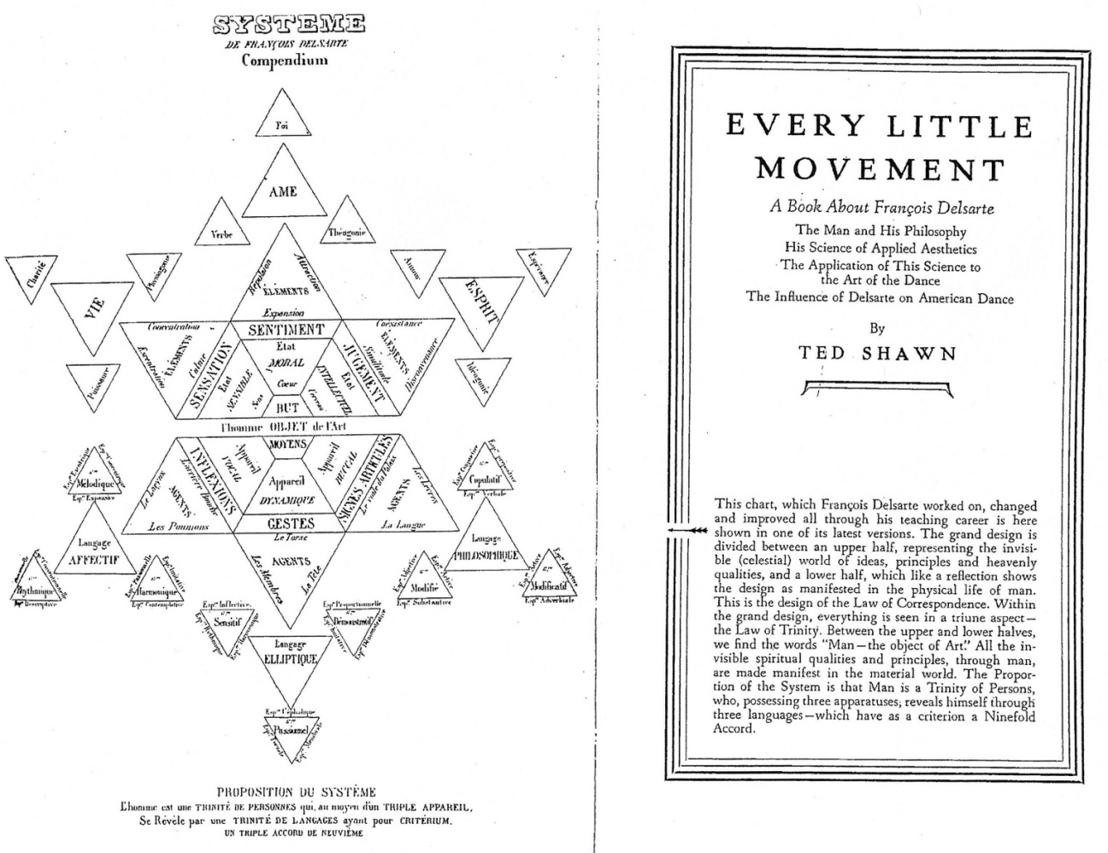

**François Delsarte’s system of ‘semeiotics,’ analyzing the three faculties (reason, sentiment, will) in relation to the three zones of the body in which they predominate. Note that each zone is further subdivided into three parts to account for the variability and nuance of expression. As the diagram indicates, Delsarte’s model is premised upon Immanuel Swedenborg’s principle of ‘correspondence’ between spiritual essences and material manifestations.**

[Source: frontispiece, Ted Shawn, (1954; 1963) *Every Little Movement: A Book about François Delsarte: The Man and his Philosophy*, Pittsfield, MA: Eagle Print and Binding.]

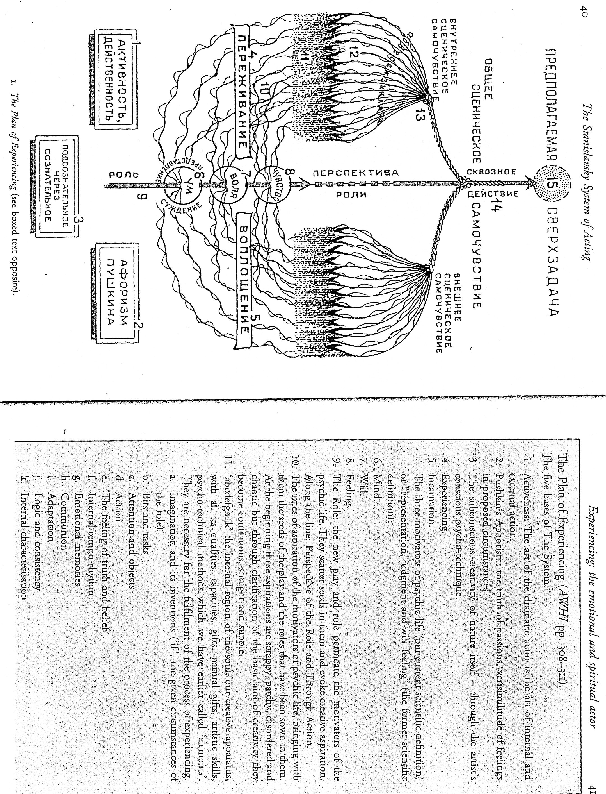

**Konstantin Stanislavsky’s ‘Plan of Experiencing.’ From bottom to top, the actor takes up the ‘role’ (#9), which moves upward through the imagination, where it is ‘experienced’ (#4), and the body, where it is ‘incarnated’ (#5), sending out electrical currents which are bound together into a full conception of the part (#14) as it moves toward realizing its superobjective (#15) in the play. Note the three faculties from which the actor draws: activity (#1), passion (#2), and consciousness (#3), which are congruent with Delsarte’s will, sentiment, and reason.**

[Source: reproduced in Rose Whyman, (2008) *The Stanislavski System of Acting: Legacy and Influence in Modern Performance*, Cambridge: Cambridge University Press.]